**Software Requirement Specifications**

# Introduction

## Purpose

This Software Requirement Specification (SRS) document outlines the functional and non-functional requirements for the AIMS (An Internet Media Store) project. It serves as a comprehensive guide for the development, testing, and deployment of the AIMS software system.

## Scope

The AIMS project aims to develop a desktop e-commerce platform enabling customers to browse, search, and purchase various media products (books, CDs, LPs, DVDs) online. The system will also facilitate product management for administrators and order processing and fulfillment.

## Intended Audience

This SRS document is intended for the following stakeholders:

* **Development Team**: Responsible for designing, implementing, and testing the AIMS software.
* **Product Managers**: Define and manage the product catalog within AIMS.
* **Administrators**: Oversee user accounts, roles, and system configurations.
* **Testers**: Verify the system's functionality and compliance with the specified requirements.
* **Project Sponsors and Stakeholders**: Provide funding and oversight for the AIMS project.

## Overview

The subsequent sections of this SRS document will elaborate on the specific functional and non-functional requirements, use case specifications, business processes, and glossary of terms relevant to the AIMS project.

# Use Case Diagrams

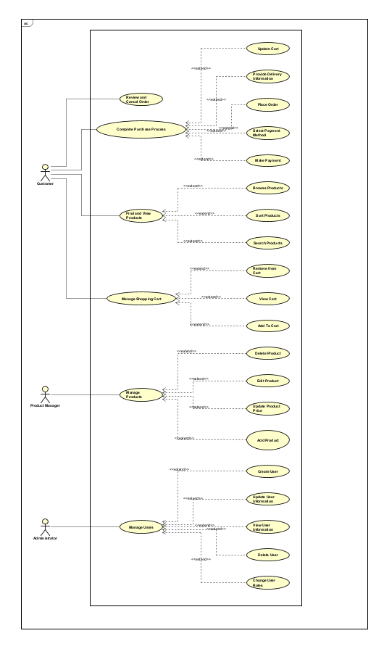

# Business Process

## Order Placement Process

* + - **Customer Browsing and Search**: The customer browses or searches for media items using various criteria (title, category, etc.).
    - **Product Selection and Cart Management**: The customer selects desired items and adds them to their cart, potentially updating quantities or removing items.
    - **Checkout Initiation**: The customer proceeds to checkout, indicating their intent to place an order.
    - **Delivery Information**: The customer provides delivery details (name, address, etc.) and potentially opts for rush delivery if eligible.
    - **Inventory and Rush Order Validation**: The system checks inventory availability and rush order eligibility based on product and delivery address.
    - **Order Confirmation and Payment**: The system calculates fees, displays the invoice, and redirects the customer to VNPay for payment processing.
    - **Payment Processing**: VNPay handles the payment transaction and notifies AIMS of the result.
    - **Order Finalization**: Upon successful payment, AIMS confirms the order, sends an email notification to the customer, and records the order details.

## Order Management Process

• **Order Review**: The product manager reviews pending orders, accessing details like customer information, ordered items, and payment status.

• **Order Approval/Rejection**: The product manager approves or rejects orders based on various factors (inventory, product availability, etc.).

• **Order Cancellation (Customer)**: The customer can cancel a pending order before it's approved, triggering a refund process through VNPay.

• **Order Status Updates**: The system updates the order status (pending, approved, canceled) and notifies the customer accordingly.

# Use case specifications

## Use Case “Place Order”

### Use case code

UC005

### Brief Description

This use case describes the interaction between the customer and the AIMS software when the customer chooses to place a rush order, requesting delivery within 2 hours. The system checks if rush delivery is available for the products and delivery location, calculates the rush delivery fee, and processes the order accordingly.

### Actors

* Customer

### Preconditions

* There is at least one item in the customer's cart.
* Rush order delivery is available for the selected products and location.

### Basic Flow of Events

Step 1. The customer requests to place a rush order from the cart.

Step 2. The AIMS software checks the availability of the products for rush delivery.

Step 3. The AIMS software checks if the delivery address supports rush delivery (inner city of Hanoi).

Step 4. If eligible, the AIMS software displays the rush order delivery information form, including available time slots for delivery.

Step 5. The customer enters rush delivery time and instructions (if any).

Step 6. The AIMS software calculates and updates the order information with the rush delivery fee.

Step 7. The customer reviews and confirms the rush order.

Step 8. The AIMS software processes the order, updates the inventory, and sends a confirmation email.

Step 9. The rush order is delivered within 2 hours, as per the selected delivery time.

### Alternative Flows

|  |  |  |  |  |
| --- | --- | --- | --- | --- |
| No | Location | Condition | Action | Resume location |
| 1. | At Step 3 | If rush delivery is not available for the delivery address. | The AIMS software notifies the customer that rush delivery is not available.  The customer is prompted to update the delivery address or continue with regular delivery. | End use case |
| 2. | At Step 2 | If some products in the cart are not eligible for rush delivery. | The AIMS software informs the customer which items are not eligible for rush delivery.  The customer can choose to continue with eligible products for rush delivery or adjust the cart.  The AIMS software recalculates the delivery fees accordingly. | At Step 3 or end use case |

### Input Data

|  |  |  |  |  |  |
| --- | --- | --- | --- | --- | --- |
| No | Data fields | Description | Mandatory | Valid condition | Example |
| 1 | Receiver Number |  | Yes | string | Do Minh Hieu |
| 2 | Phone Number |  | Yes | 10 digits | 0987654321 |
| 3 | Province | Choose from a list | Yes |  | Hanoi |
| 4 | Address |  | Yes | string | 34 Alley of Tran Thai Tong street, Cau Giay district |
| 5 | Shipping Instructions |  | No | string | Leave with concierge |
| 6 | Delivery Time | Rush Order | Yes | timestamp | 10:00 AM - 12:00 PM |

### Output Data

|  |  |  |  |  |
| --- | --- | --- | --- | --- |
| No | Data fields | Description | Display format | Example |
| 1 | Title | Title of a media product |  | DVD Movie Escape |
| 2 | Price | Price of the corresponding media product | * Comma for thousands separator * Positive integer * Right alignment | 123,000 |
| 3 | Quantity | Quantity of the corresponding media | * Positive integer * Right alignment | 2 |
| 4 | Amount | Total money of the corresponding media | * Comma for thousands separator * Positive integer * Right alignment | 246,000 |
| 5 | Subtotal | Total amount of all products in the order | * Comma for thousands separator * Positive integer   Right alignment | 2,316,600 |
| 6 | Rush delivery fee |  | * Comma for thousands separator * Positive integer   Right alignment | 30,000 |
| 7 | Selected delivery time |  | Date and time |  |
| 8 | Total |  | * Comma for thousands separator * Positive integer * Right alignment | 2,346,600 |

*Table 2-Output data of order information and shipping fee*

|  |  |  |  |  |
| --- | --- | --- | --- | --- |
| No | Data field | Description | Display format | Example |
|  | Customer name |  | String | Do Minh Hieu |
|  | Phone number |  | 10 digits | 0987654321 |
|  | Address |  | String | 34 Alley of Tran Thai Tong street, Cau Giay district |
|  | Total amount |  | * Right alignment * Vietnamese currency * Vietnamese locale | 1.200.000 VND |
|  | Transaction ID |  |  |  |
|  | Transaction content |  |  |  |
|  | Transaction date |  | dd/mm/yyyy | 05/10/2023 |

### Post-Conditions

* **Success:** A rush order is created, and the customer receives confirmation via email. The order is processed for delivery within the selected 2-hour timeframe.
* **Failure:** If the rush order cannot be completed (due to invalid address or product availability), the customer is prompted to adjust the order.

## Use Case “Pay Order”

### Use case code

UC004

### Brief Description

This use case describes the interaction between the customer, the AIMS software, and VNPay when the customer desires to pay for an order. The customer initiates the payment process, and the AIMS software facilitates the transaction through VNPay.

### Actors

* + Customer
  + VNPay

### Preconditions

* The order must be placed and invoiced.
* The customer has a valid payment method available (credit card).

### Basic Flow of Events

Step 1. The AIMS software displays the invoice.

Step 2. The customer requests to pay the invoice.

Step 3. The AIMS software redirects the customer to VNPay for payment processing.

Step 4. VNPay processes the payment and sends the payment result to AIMS.

Step 5. The AIMS software saves the invoice and payment transaction.

Step 6. VNPay notifies the AIMS system about the success or failure of the payment.

Step 7. The AIMS software displays the transaction information (successful or failed).

### Alternative Flows

|  |  |  |  |  |
| --- | --- | --- | --- | --- |
| No | Location | Condition | Action | Resume location |
| 1. | At Step 5 | If the customer cancels the payment transaction. | * VNPay notifies AIMS that the payment was canceled. * The AIMS software redirects the customer back to the order screen to retry or leave the process. | At Step 1 |

### Input Data

|  |  |  |  |  |  |
| --- | --- | --- | --- | --- | --- |
| No | Data fields | Description | Mandatory | Valid condition | Example |
| 1 | Receiver Number |  | Yes | string | Do Minh Hieu |
| 2 | Phone Number |  | Yes | 10 digits | 0987654321 |
| 3 | Province | Choose from a list | Yes |  | Hanoi |
| 4 | Address |  | Yes | string | 34 Alley of Tran Thai Tong street, Cau Giay district |
| 5 | Shipping Instructions |  | No | string | Leave with concierge |
| 6 | Delivery Time | Rush Order | Yes | timestamp | 10:00 AM - 12:00 PM |

### Output Data

|  |  |  |  |  |
| --- | --- | --- | --- | --- |
| No | Data fields | Description | Display format | Example |
|  | Title | Title of a media product |  | DVD Movie Escape |
|  | Price | Price of the corresponding media product | * Comma for thousands separator * Positive integer * Right alignment | 123,000 |
|  | Quantity | Quantity of the corresponding media | * Positive integer * Right alignment | 2 |
|  | Amount | Total money of the corresponding media | * Comma for thousands separator * Positive integer * Right alignment | 246,000 |
|  | Subtotal before VAT | Total amount of all products in the order | * Comma for thousands separator * Positive integer   Right alignment | 2,316,600 |
|  | Shipping fee |  | 30,000 |
|  | Subtotal |  | 2,346,600 |

*Table 2 - Output data of the invoice*

|  |  |  |  |  |
| --- | --- | --- | --- | --- |
| No | Data field | Description | Display format | Example |
|  | Customer name |  | String | Do Minh Hieu |
|  | Phone number |  | 10 digits | 0987654321 |
|  | Province |  | String | Hanoi |
|  | Address |  | String | 34 Alley of Tran Thai Tong street, Cau Giay district |
|  | Total amount |  | * Right alignment * Vietnamese currency * Vietnamese locale | 1.200.000 VND |
|  | Transaction ID |  |  | TXN20240911_12345ABC |
|  | Transaction content |  |  | Payment for Order #AIMS20240911_001, Customer: John Doe, Total: 1,200,000 VND |
|  | Transaction date |  | dd/mm/yyyy | 05/10/2023 |

*Table 3 – Transaction Information*

### Post-Conditions

* The order is successfully paid, and transaction information is saved in the AIMS system. A confirmation email is sent to the customer.
* If the payment fails, no transaction is recorded, and the customer can attempt payment again.

# Supplementary Requirements

* **Performance**:
  + The system should support up to 1,000 concurrent users without significant performance degradation.
  + The maximum response time should be 2 seconds under normal conditions and 5 seconds during peak hours.
  + The system should be able to operate continuously for 300 hours without failure.
  + In the event of an incident, the system should be able to resume normal operation within 1 hour.
* **Security**:
  + Customer data, including personal and payment information, should be securely stored and encrypted.
  + Access controls should be implemented to prevent unauthorized actions, such as product managers deleting more than 30 products or updating product prices beyond the allowed range.
  + User passwords should be hashed and salted to protect against unauthorized access.
* **Usability**:
  + The user interface should be intuitive, user-friendly, and easy to navigate for both customers and administrators.
  + Clear instructions and error messages should be provided to guide users through the various processes.
  + The system should be accessible to new users with minimal training or assistance.

# Glossary

• **AIMS**: An Internet Media Store

• **UC**: Use Case

• **VNPay**: The payment gateway integrated into AIMS

• **VAT**: Value-Added Tax (10%)